CREDIT CARD WEEKLY STATUS REPORT

- Business Problem
To develop a comprehensive credit card weekly dashboard that provides insights into key performance metrics and trends, enabling stakeholders to monitor and analyze credit card operations effectively.

- Objectives
- Monitor revenue and transaction trends
- Analyze customer behavior and segmentation
- Identify spending patterns
- Support data-driven decision making

- Dataset Overview
- Transaction data
- Customer demographics
- Spending categories
- Geographic distribution

- Executive Summary
The dashboard reveals that the business is generating:
- ₹55M total revenue
- 45M transactions
- ₹7.8M interest earned

- Key Highlights:
- Majority revenue comes from Blue card users
- Spending is concentrated in essential categories
- Professionals and businessmen are top contributors
- Online transactions are very low
- Customer satisfaction is moderate (3.19)

- Overall:
The business is stable but has strong growth opportunities, especially in digital payments and premium card adoption.

Revenue Analysis
- Revenue by Card Category
- Blue Card: ₹46M
- Silver: ₹6M
- Gold: ₹2M
- Platinum: ₹1M

- Analysis:
- Blue cards contribute ~80–85% of total revenue
- Premium cards (Gold, Platinum) have very low usage
- Insight:
- Customers prefer basic credit cards
- There is a major opportunity to upsell premium cards

- Quarterly Revenue Trends
- Q1: ₹14.0M
- Q2: ₹13.8M
- Q3: ₹14.2M
- Q4: ₹13.3M

- Analysis:
- Revenue is consistent across quarters
- Slight peak in Q3 and dip in Q4

- Insight:
- Business has stable performance
- No strong seasonal dependency

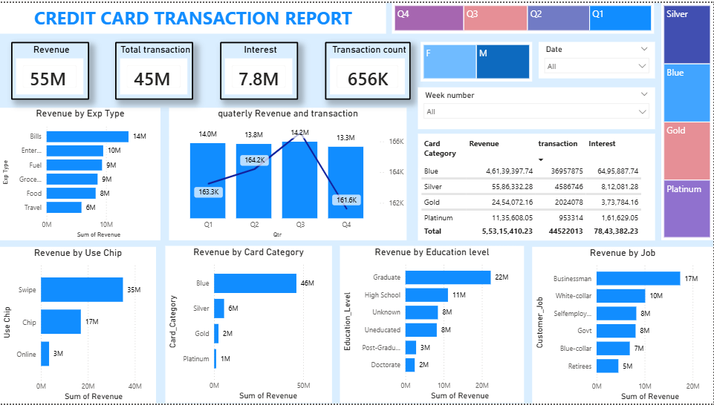

- Transaction Volume
- ~161K to 164K transactions per quarter

- Insight:
- Customer activity is consistent and predictable

Spending Behavior Analysis

- Revenue by Expense Type
Top categories:
- Bills: ₹14M
- Entertainment: ₹10M
- Fuel: ₹9M
- Grocery: ₹9M
- Food: ₹8M
- Travel: ₹6M

- Analysis:
- Spending is heavily focused on essential needs

- Insight:
- Credit cards are used for daily life expenses
- Not heavily used for luxury or travel

- Payment Mode Analysis
- Swipe: ₹35M
- Chip: ₹17M
- Online: ₹3M
- Analysis:
- Swipe dominates (~65%)
- Online usage is very low (~5%)
- Insight:
- Customers are still reliant on physical transactions
- Huge opportunity for digital transformation

- Education Level
- Graduates: ₹22M
- High School: ₹11M
- Others: lower

- Insight:
- Educated individuals are primary contributors

- Job Role
- Businessman: ₹17M
- White-collar: ₹10M
- Self-employed: ₹8M
- Govt: ₹8M
- Others: lower

- Analysis:
- Professionals dominate usage

- Insight:
- High-income occupations drive revenue

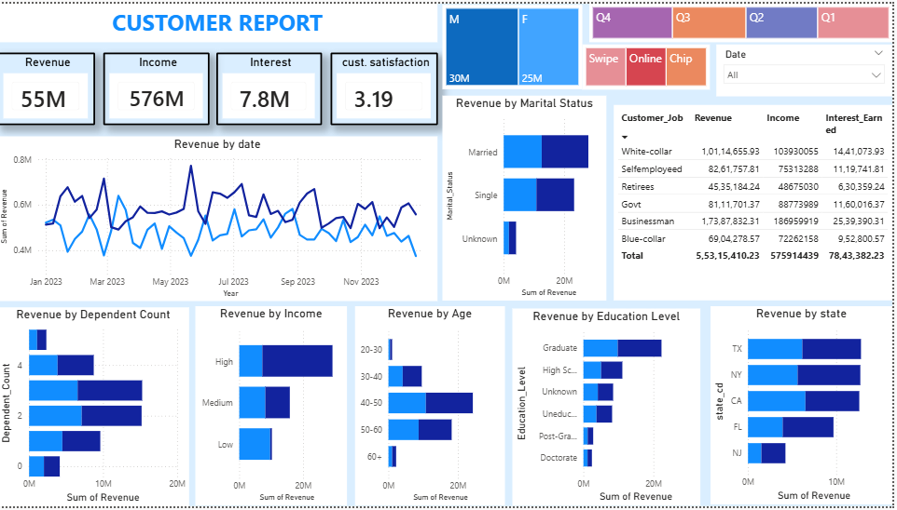

- Revenue by State
Top states:
- Texas (TX)
- New York (NY)
- California (CA)
- Florida (FL)
- New Jersey (NJ)

- Insight:
- High revenue comes from economically strong regions

- Age Group Analysis
- Highest: 30–50 years

- Insight:
- Middle-aged population is the core customer base

- Marital Status
- Married customers contribute more

- Insight:
- Family-oriented individuals have higher spending patterns

- Revenue Over Time
- Revenue trend is stable throughout the year

- Insight:
- Business performance is predictable and steady

- Customer Satisfaction
- Score: 3.19 / 5

- Analysis:
- Average satisfaction level

- Insight:
- Customer experience needs improvement

- Key Business Insights

Major Findings:
- Blue cards dominate → low premium adoption
- Spending focused on daily essentials
- Professionals are key revenue drivers
- Online transactions are very low
- Revenue is stable but not rapidly growing
- Customer satisfaction is moderate

- DAX Queries

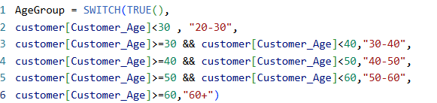

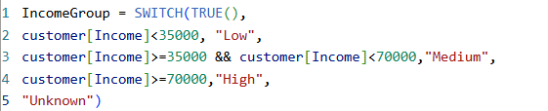





- Recommendations

1. Increase Premium Card Adoption
- Offer upgrade benefits
- Loyalty rewards

2. Promote Online Transactions
- Cashback offers
- Digital payment incentives

3. Target High-Value Customers
- Businessmen
- White-collar professionals

4. Improve Customer Satisfaction
- Better support
- Faster issue resolution

5. Region-Based Strategy
- Focus marketing on top-performing states

- Conclusion
The Power BI dashboard provides a comprehensive and actionable view of credit card operations.
Strengths:
- Stable revenue
- Clear customer segmentation
- Strong usage in daily spending
Weaknesses:
- Low digital adoption
- Low premium card usage
- Moderate satisfaction score

